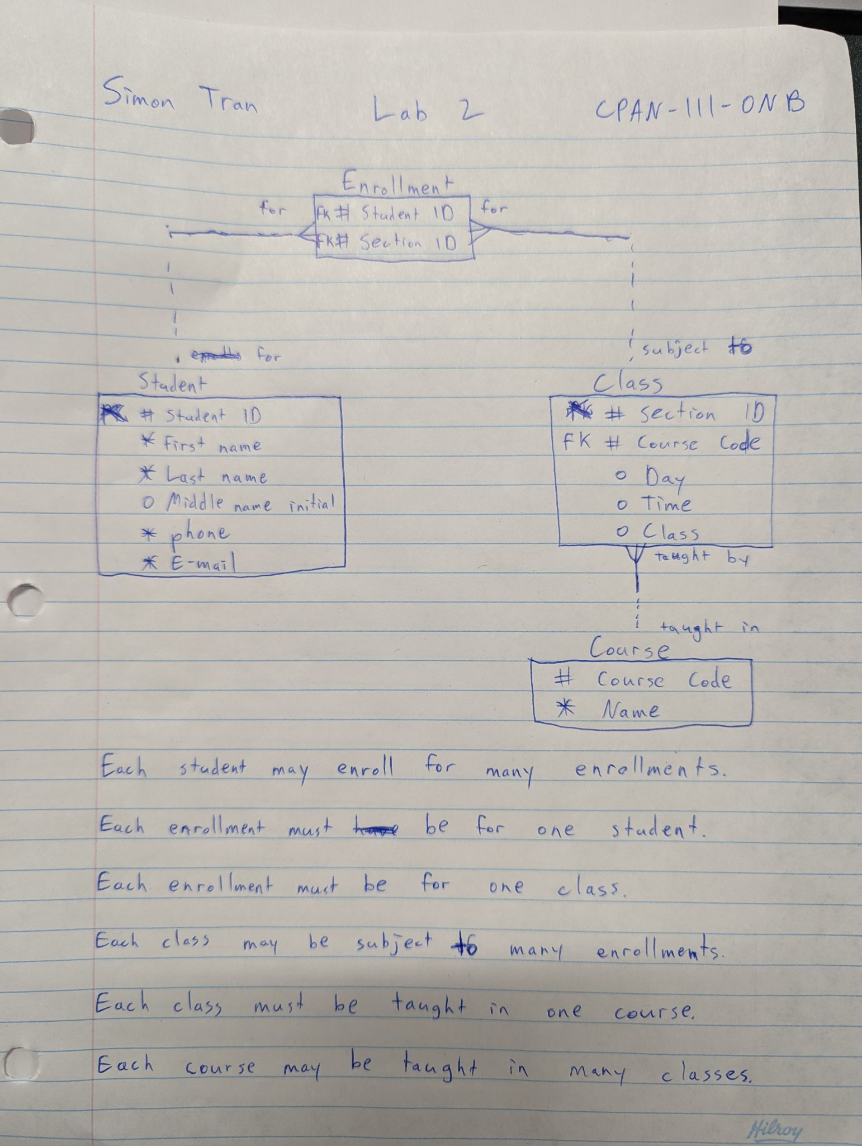

Each student may enroll for many enrollments.

Each enrollment must be for one student.

Each enrollment must be for one class.

Each class may be subject to many enrollments.

Each class must be taught in one course.

Each course may be taught in many classes.